

**Green University of Bangladesh**

**Department of Computer Science and Engineering (CSE)**

**Faculty of Sciences and Engineering**

**Semester: (Spring, Year: 2023), B.Sc. in CSE (Day)**

**LAB REPORT NO: 02**

**Course Title: Engineering Drawing**

**Course Code: CSE-208 Section: DC**

**Lab Experiment Name: 2D Floor Planning**

**Student Details**

|  |  |  |
| --- | --- | --- |
| **Name** | | **ID** |
|  | Md. Sohanur Rahman | 213902106 |

**Lab Date : 05.05.2023**

**Submission Date : 16.06.2023**

**Course Teacher’s Name : Rusmita Halim Chaity**

**[For Teachers use only: Don’t Write Anything inside this box]**

|  |
| --- |
| **Lab Report Status**  **Marks: ………………………………… Signature: .....................**  **Comments: .............................................. Date: ..............................** |

**LAB REPORT TEMPLATE**

**1. TITLE OF THE LAB EXPERIMENT**

2D Floor Planning.

**2. OBJECTIVES/AIM**

* To gain the basic knowledge of 2D drawing tools and techniques.
* To implement the skills to develop basic 2D drawings.
* To gain Knowledge about autoCad and it’s tools. Example: Line, Circle, Copy, Move, Rectangle, polygon etc.
* To implement of the given 2D task in Lab Report.

**3. PROCEDURE / ANALYSIS / DESIGN**

**Problem Analysis:** 2D drafting and drawing is the process of creating and editing technical drawings, as well as annotating designs.

**3.1. Setting Drawing Limits:** For setting drawing limits Type LIMITS and press enter. Command line will prompt “Specify lower left corner or [ON/OFF] <00-000,00-000>:” simply press enter to accept the default values of the lower left corner which is 0,0.

**3.2. Drawing and Modify tools:**

**1. Line**

Shortcut Key: L

Line command draws a straight line from one point to another. With the help of line, we can create numerous line segments. All segments are separate to each other. Below points are describing the process of line:

* Go to the draw panel
* Click on line tool or enter its short command L.
* Click a point anywhere on screen
* Then specify a value of distance and press double enter

**2. Circle**

Shortcut key: C

It draws a circle to the radius and center point. Below points are describing the process of circle tool:

* Go to the drawing panel
* Click on the circle tool or enter short command C
* Click a point on screen.
* Enter R(radius) or d (diameter)
* Then give a specify value and press enter.
* Through all given steps, your circle will be making.

**3. Move**

Shortcut key: M Move command is used to move any object to the other side in a specialized distance.

Below described the process of move tool:

• Go to the draw panel

• Click on the move tools or enter short command M

• Select the object and press enter

• Click on the base point and move objects in any direction

**4. Trim**

Shortcut key: Tr

It is used for cutting unwanted line and edges. We have described the process of trim tool below:

* Go to modify panel
* Click on trim tool or short enter command tr
* Select the object ( clicking right button of mouse) and press enter
* Then click any edge, if we want to remove and press enter

**5. Copy**

Shortcut Key: Co

* Go to modify panel
* Click copy tool or enter short command Co

**4. IMPLEMENTATION**

**Detailed steps to drawing of Lab Exercise:**

**Step1:** First draw the room, kitchen etc according their given measurments. Then draw the door using the autocad tools.

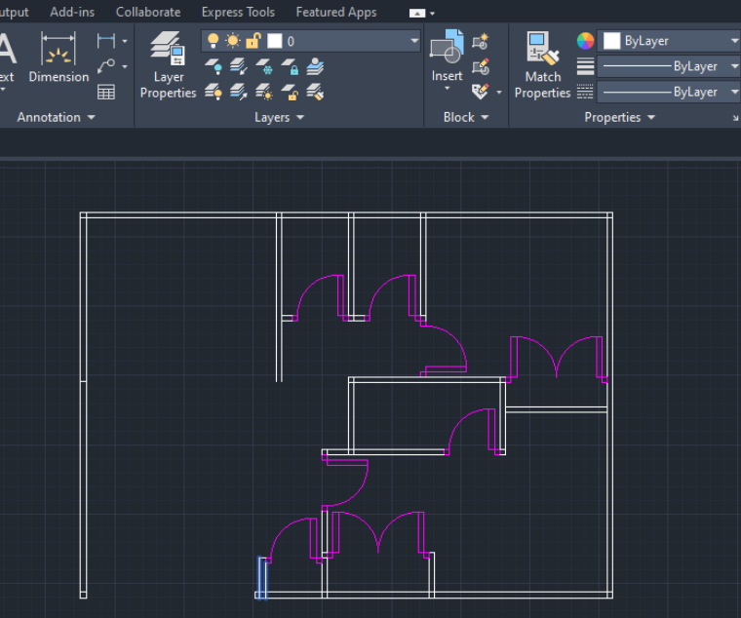

Figure: 4.1: First step of drawing

**step2:** Now, draw the window using autocad tools. Then fixed them into the position given in the image.

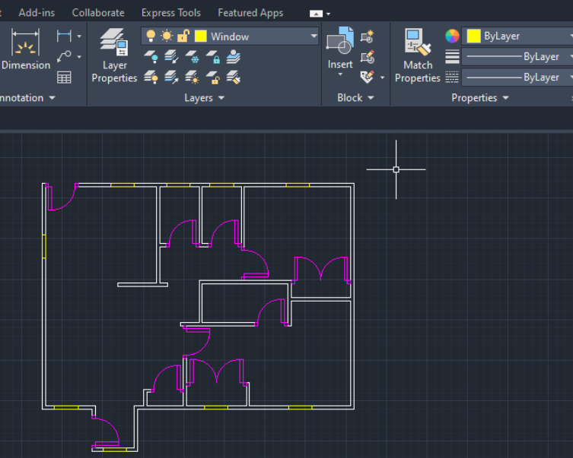

Figure: 4.2: Second steps of drawing

**step3:** Finally, take the bed, light, lamp, flower etc using command line from the autocad. And puts them in the given position into the image.

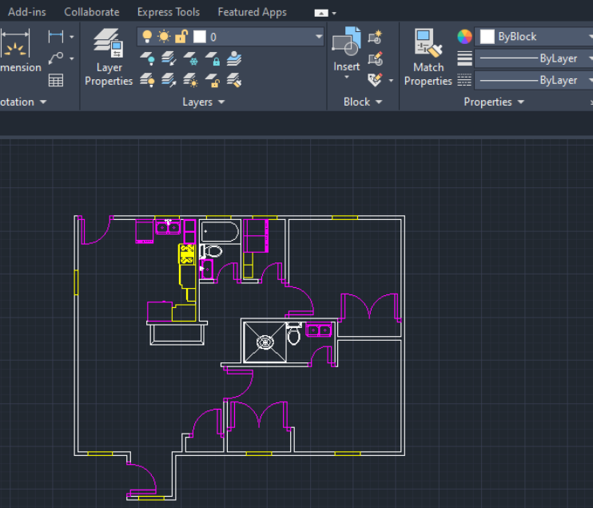

Figure: 4.3 Final steps of drawing

**5. TEST RESULT / OUTPUT**

The result or output of the given task is given below. Where we can see that when I am goes to measure the door, window, and length. It can measure successfully but the distance between wall is not measure correctly. It is the drawbacks of this experiment.

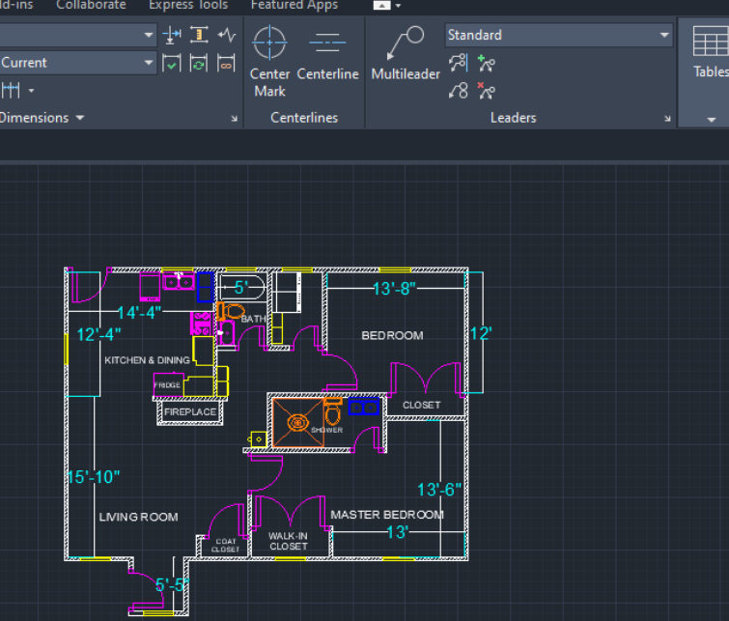

Figure: 5.1: Final Drawing

**6. ANALYSIS AND DISCUSSION**

Based on the focused objective(s) to understand about the advance knowledge of 2D drawing and implement those to design a real life object. And the lab exercise made us more confident towards the fulfilled of the objectives. And in this experiment I am learn about some basic drawing tools and how to implement the given task using those tools. When I go to solved the given task I face some problem. But I am overcome this problem by analyzing in a long time. And finally my Lab Experiment-2 is done. This is all about of this lab experiment 2.